**PSG College of Technology, Coimbatore – 04**

**Department of Applied Mathematics and Computational Sciences**

**Python – Model Lab Test**

1. Consider a list of numbers with two operations.

**insert number** — adds the specified number to the end of the list.

**delete numbe**r — removes the first occurrence of the specified number from the list. If the list does not contain the number specified, no changes are performed.

**For example**: the result of the insertion of a number 4 to the list [1, 2, 1] is the list [1, 2, 1, 4]. If we delete the number 1 from this list, we get the list [2, 1, 4], but if we delete the number 3 from the list [1, 2, 1, 4], the list stays unchanged.

The list is homogeneous if it contains at least two equal numbers and the list is heterogeneous if it contains at least two different numbers. For example: the list [2, 2] is homogeneous, the list [2, 1, 4] is heterogeneous, the list [1, 2, 1, 4] is both, and the empty list is neither homogeneous nor heterogeneous. Write a program that handles a number of the operations insert and delete on the empty list and determines list’s homogeneity and heterogeneity after each operation.

**Input :** The first line of the input contains an integer number n - the number of operations to handle (1 ≤ n ≤ 100). Following n lines contain one operation description each. The operation description consists of a word “insert” or “delete”, followed by an integer number k — the operation argument

**Output :** For each operation output a line, containing a single word, describing the state of the list after the operation:

• “both” — if the list is both homogeneous and heterogeneous.

• “homo” — if the list is homogeneous, but not heterogeneous.

• “hetero” — if the list is heterogeneous, but not homogeneous.

• “neither” — if the list is neither homogeneous nor heterogeneous.

**Example**

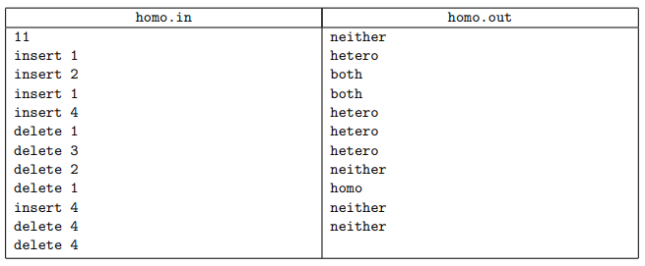

1. You have come up with an idea for a board game. The game is played on a board that is made up of nxn numbered squares. The centre square contains the number 1 and the other numbers are arranged in an anticlockwise spiral outwards (first moving downwards, then to the right, then upwards, then to the left, then downwards again, and so on). Figure A.1 displays the 5 x 5 squares in the middle of the board. When playing the game, players will only be able to move up, left, down and right. To help work out the rules for the game, you would like to know the shortest distance between two squares on the board using only these moves.

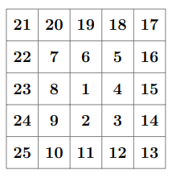

**Figure A.1: The middle 25 squares**

**Input** : The input consists of a single line containing two integers a, which is the starting square, and, which is the ending square.

**Output** : Display the shortest distance between a and b.

